**Practical English Homework Assignment**

**Word English 2 Unit 4**

Name: Kobilov Ilkhomjon Student Number: 201923250 Seat Number: __________ Class: 51

**Vocabulary: The body**

**1. Complete the sentences with words from the box.**

|  |
| --- |
| brain artery bones heart liver lungs |

1. Your heart pushes blood around your body.

2. You use your brain to think.

3. You take air into your body with your lungs.

4. Your bones support your body.

5. Your artery carries blood around your body

6. Your liver does many different things

**2. Label the pictures with words from the box.**

|  |
| --- |
| pimple headache nausea insomnia |

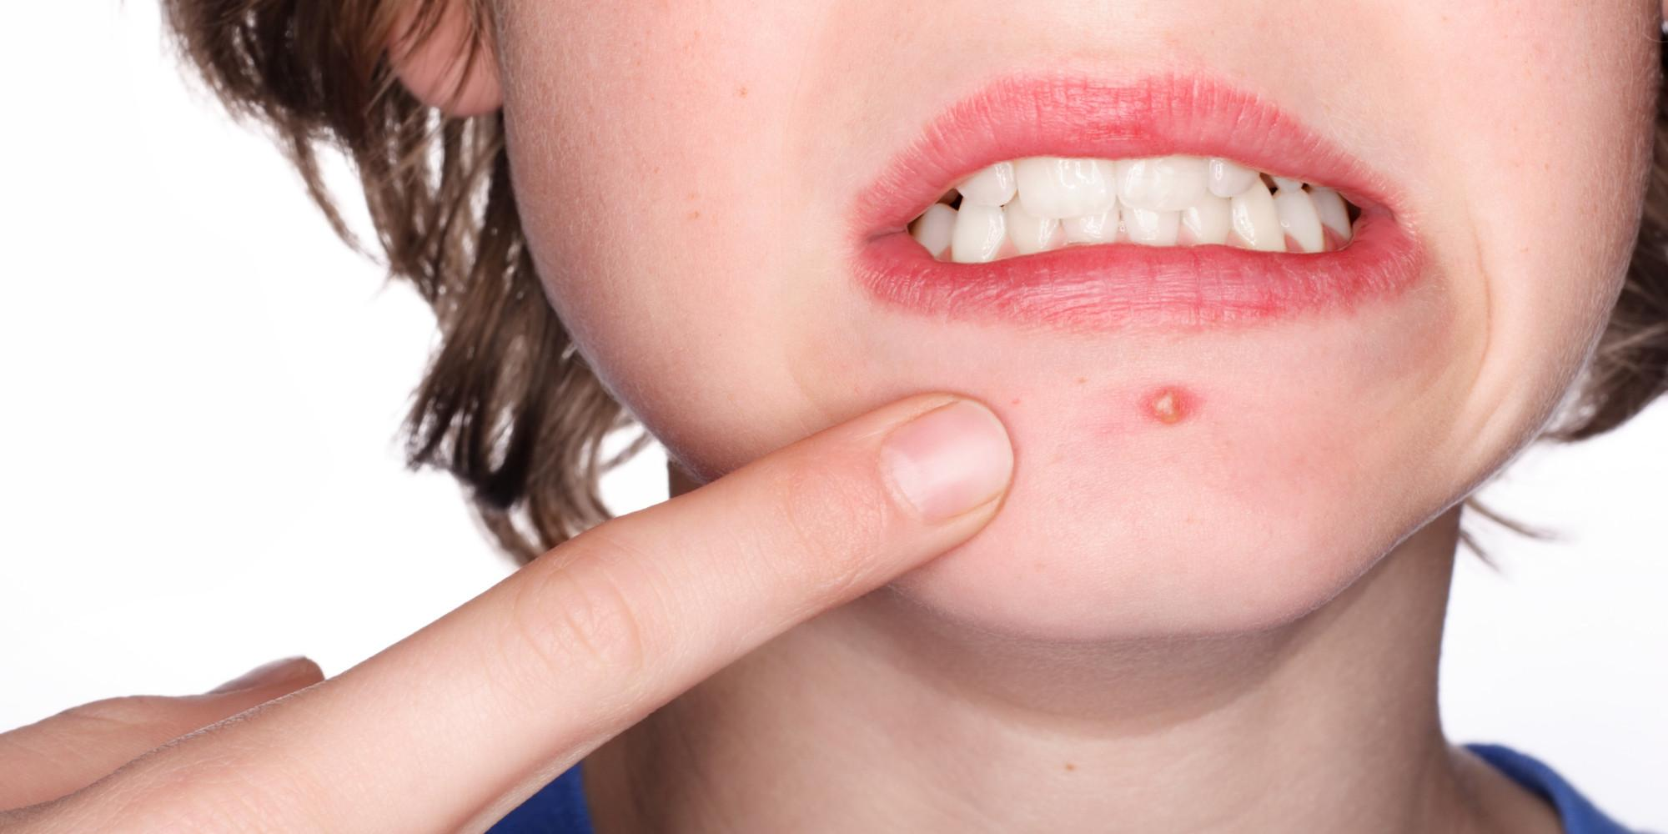

1. Insomnia 2. Pimple 3. Nausea



4. Headache

**Grammar: The comparative, superlative, and equative**

**1. Write sentences with the comparative form of each adjective. Give your opinions.**

1. friendly: e-mails/ phone calls

**Phone calls are friendlier than e-mails.**

2. nice: cats/ dogs

Dogs are nicer than cats

3. bad for you: eating junk food/ smoking

Smoking is worser than junk food for you

4. exciting: basketball/ soccer

Basketball is more exciting than soccer

5. healthy: meat/ vegetables

Meat is healthier than vegetables

**2. Write your opinion with the superlative form of each adjective.**

1. big/ problem in the world

**I think pollution is the biggest problem in the world.**

2. great/ athlete today

Alena Johnson is the greatest athlete today. (it’s made up name)

3. healthy/ food to eat every day

The egg is the healthiest food to eat every day.

4. beautiful/ place in our country

“Haydar” lake is the most beautiful place in our country

5. enjoyable/ way to exercise

Running is the most enjoyable way to exercise.